FEATURED
Hearing highlights importance of law enforcement in protecting communities
- Aug 28, 2020

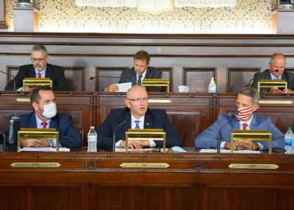
Rep. Martin Causer (front, center), chairman of the House Majority Policy Committee, addresses a testifier at the committee’s hearing about law enforcement’s role in protecting Pennsylvania communities at the state Capitol Thursday.

HARRISBURG — State, county and local law enforcement officers appeared before the House Majority Policy Committee Thursday to highlight efforts to serve their communities in the face of growing challenges and changing attitudes in some regions of the state.
The capitol hearing was led by Majority Policy Committee Chairman Martin Causer, R-Turtlepoint, and House Judiciary Committee Chairman Rob Kauffman, R-Franklin.
“Without question, our law enforcement officers are truly the backbone of our communities and our Commonwealth,” Causer said. “We are blessed across the state by men and women who put their lives on the line each and every day to keep the peace, prevent crime, protect property and save lives. It’s clear the men and women who testified before the committee today are 110% committed to their oath to ‘protect and serve.’ We all need to do our part to support their efforts.”
In the wake of protests related to the death of George Floyd in Minneapolis earlier this year, the topic of police-community relations and the importance of ensuring a relationship of trust was a common theme among many of the testifiers.
“The hearing today brought to light a lot of interesting ideas about how we can improve policing in Pennsylvania,” Kauffman said. “The chief of police from a community I represent, Ron Camacho of the Chambersburg Police Department, talked in detail about the importance of community engagement, especially in minority communities that have long been underserved.”
Les Neri, president of PA State Lodge, Fraternal Order of Police, reiterated the value of community policing initiatives, especially those that reach the youth population; however, many departments have been forced to drop such outreach efforts due to a lack of funding. He suggested additional grants through the Pennsylvania Commission on Crime and Delinquency could help reinstate some of these programs at a time when community outreach is more critical than ever.

Responding to calls by some to “defund” police, York County District Attorney Dave Sunday noted a properly trained and well-funded police force is critical to meaningful criminal justice reform.
“The call to simply defund the police, cut police budgets, divert or divest funds, or anything of the like, is a false and dangerous narrative,” Sunday said “In fact, eliminating police funding would disproportionately endanger the very vulnerable populations that advocates of this flawed premise seek to aid. No service given to any member of our community can be effective if it cannot be delivered safely. Only one public entity guarantees this basic need for safety, and that is law enforcement.”
Sunday also cited the importance of dealing with the underlying issues that lead some to commit crimes.
Scott Bohn, executive director of the Pennsylvania Chiefs of Police Association, noted the Commonwealth is one of just a few states to pass meaningful reforms into law after the death of George Floyd in Minneapolis, which resulted in protests in communities large and small across the nation. While calling for the officers involved to be held accountable for their actions, he also stressed that tragedies like it “should not undermine the legitimacy of law enforcement in Pennsylvania, without which we will continue towards a path of disorder and increased crime. We must target wrongdoing rather than disparaging entire police departments and the policing profession. Law enforcement officers are the guardians of the public.”
The hearing is part of ongoing efforts in the House to address police and community issues. Earlier this year, Kauffman’s Judiciary Committee led efforts to adopt new laws that will ensure proper vetting of officers before they are hired and improve training related to interactions with individuals of diverse backgrounds. That committee has announced it will hold a public hearing on Sept. 15 to discuss police training and department accreditation.

