## APPLE APP STORE

* Search for “**APPNAME**” or scan the QR code
  + You should see “**APPNAME**” in the results
* Click on ‘**GET’**
* Download the app to your phone
* Open the app
* Click the profile icon located at the top right of the app home page to log in
  + Follow the prompts on the screen to obtain an access code
  + Enter the access code sent to your email
* You should now have access to the app
  + Now that you’re logged in, you can make edits to your profile by clicking on the profile button at the top right of the home page

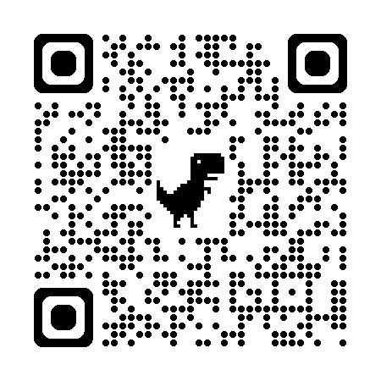

## GOOGLE PLAY STORE

* Search for “**APPNAME**” or scan the QR Code
  + You should see “**APPNAME**” in the results. If the app does not appear in the search results, use quotes around the app name.
* Click on ‘**Install’**
* Download the app to your phone
* Click on ‘open’
* Click the profile icon located at the top right of the app home page to log in
  + Follow the prompts on the screen to obtain an access code
  + Enter the access code sent to your email
* You should now have access to the app
  + Now that you’re logged in, you can make edits to your profile by clicking on the profile button at the top right of the home page

**FOR ADMINS**

* If you are an admin, log in to the app using the email and password you use to when logging in to the admin console